Game Design Document

Fill up the following document

1. Write the title of your project.

# “Come on india let’s football”

1. What is the goal of the game?

Spread craze of football in india.you have to earn points.and win the game.

1. Write a brief story of your game.

Pallavi is making multiplayer a game of football she has two reason to make it.

1_We all know that there is not much craze for football in india .but there are many talented footballers in india.if we do not show craze towards football,then many talented footballers will not get a chance to show their talent.

2_Pallavi is a biggest fan of sunil chhetri,ronaldo,messi.and she

want’s to play football but she doesn’t have anyone to play football.

So she thought let’s make a game for himself and for people like him.

which will make feel like playing football.

This game is little diffrent the real football .there will be only two players in this game,one you and one other player.

1. Which are the playing characters of this game?

* Playing characters are the ones who respond to the user based on the input from the user.
* Cars, monkeys, dinos, wizards, etc., are the playing characters in the game.

|  |  |  |
| --- | --- | --- |
| Number | Character Name | What can this character do? |
| 1 | you | Playing the game |
| 2 | Second player | Playing the game |
| 3 | football | All the game based on it. |
| 4 |  |  |
| 5 |  |  |
| 6 |  |  |
| 7 |  |  |
| 8 |  |  |

1. Which are the Non-Playing Characters of this game?

* Non-Playing characters are the ones that don't have an action or behavior when the user interacts with the game.
* Hurdles, stones, bananas, coins, etc., are non-playing characters in the game.

|  |  |  |
| --- | --- | --- |
| Number | Character Name | What can this character do? |
| 1 | walls | Make edges of ground |
| 2 | goals | Goal of the game |
| 3 |  |  |
| 4 |  |  |
| 5 |  |  |
| 6 |  |  |
| 7 |  |  |
| 8 |  |  |

Draw your imagination of this game. What does this game look like?

* Draw the game either on your computer or on paper.
* Add images of the game scenes to show each of the playing and non-playing characters at least once.

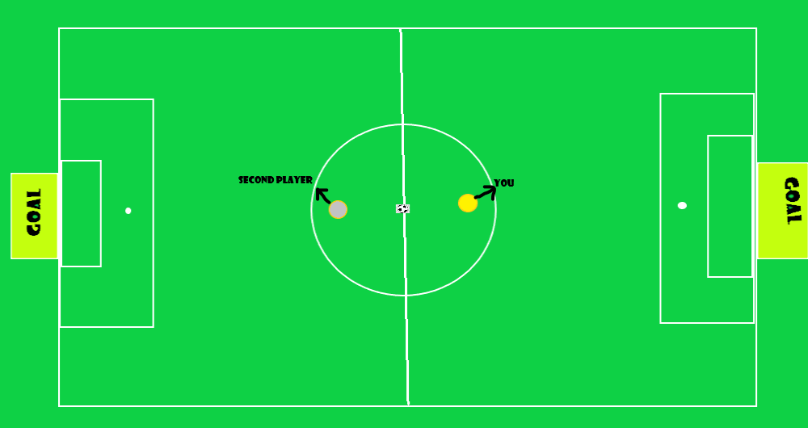

How do you plan to make your game engaging?

i use atractive animation and i always try to make a good story of my game.